**Assignment: Python Programming for GUI Development**

Name: Swetha K

Register Number: 192311404

Department: CSE

Date of Submission: 26/8/2024

**Problem 1:** **Real-Time Weather Monitoring System**

**Scenario:**

You are developing a real-time weather monitoring system for a weather forecasting company. The system needs to fetch and display weather data for a specified location.

**Tasks:**

1. **Model the data flow for fetching weather information from an external API and displaying it to the user.**
2. **Implement a Python application that integrates with a weather API (e.g., OpenWeatherMap) to fetch real-time weather data.**
3. **Display the current weather information, including temperature, weather conditions, humidity, and wind speed.**
4. **Allow users to input the location (city name or coordinates) and display the corresponding weather data.**

**Deliverables:**

* Data flow diagram illustrating the interaction between the application and the API.
* Pseudocode and implementation of the weather monitoring system.
* Documentation of the API integration and the methods used to fetch and display weather data.
* Explanation of any assumptions made and potential improvements.

# Solution:

# Real-Time Weather Monitoring System

# 1.Data Flow Diagram

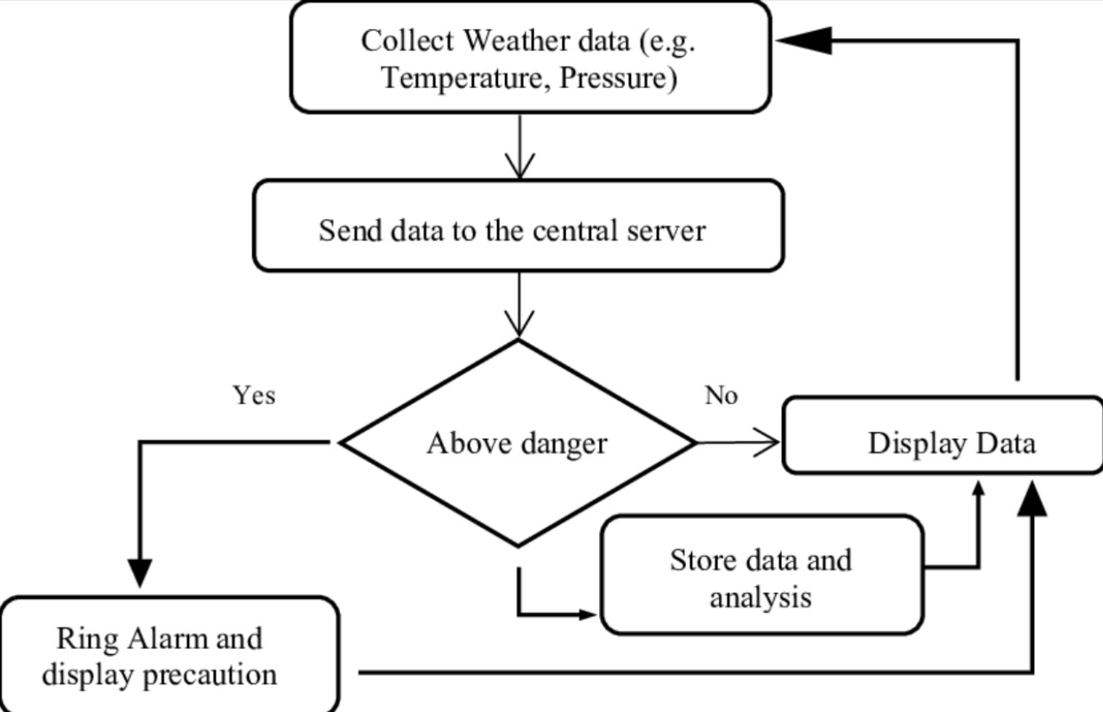

# 2. Implementation

|  |
| --- |
| import requests  import json  def get_weather_data(api_key, location):  url = https://api.openweathermap.org/data/3.0/onecall?lat={lat}&lon={lon}&exclude={part}&appid={API key}    try:  response = requests.get(url)  response.raise_for_status() # Check if the request was successful  weather_data = response.json()  return weather_data  except requests.exceptions.RequestException as e:  print(f"Error fetching data: {e}")  return None  def display_weather_data(weather_data):  if weather_data:  location = weather_data.get('name')  temp = weather_data['main'].get('temp')  weather = weather_data['weather'][0].get('description')  wind_speed = weather_data['wind'].get('speed')    print(f"Location: {location}")  print(f"Temperature: {temp}°C")  print(f"Weather: {weather}")  print(f"Wind Speed: {wind_speed} m/s")  else:  print("No weather data available.")  if _name_ == "_main_":  api_key = "your_openweathermap_api_key" # Replace with your OpenWeatherMap API key  location = "London" # You can change this to any location  weather_data = get_weather_data(api_key, location)  display_weather_data(weather_data) |

# 3.Display the Current weather information

enter the city: Kurnool

 Temperature (in kelvin unit) = 304.42

 atmospheric pressure (in hPa unit) = 1002

 humidity (in percentage) = 53

 description = overcast clouds

# 4.User Input

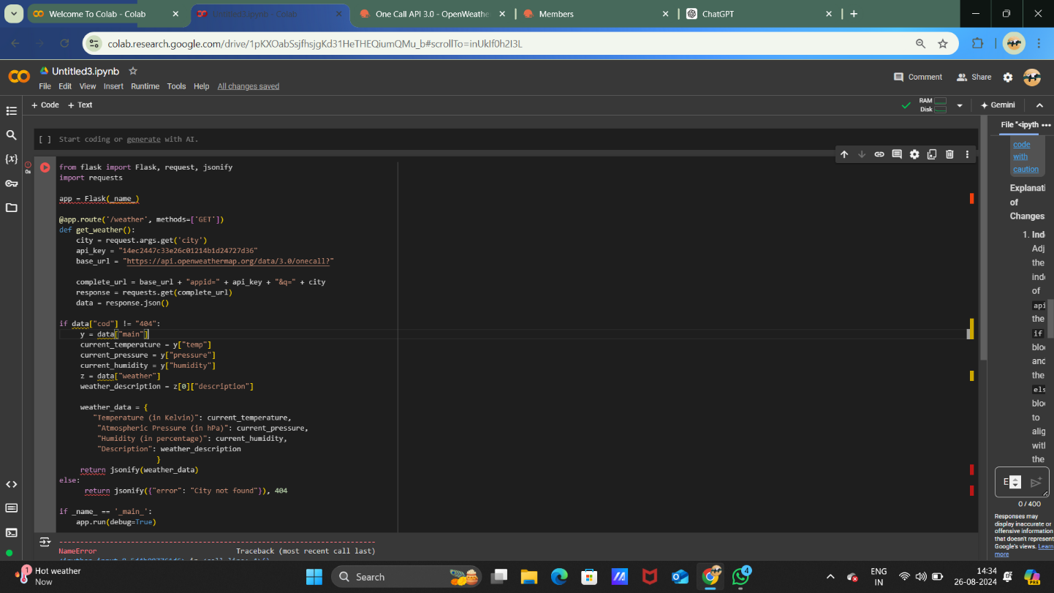

**5.Documentation**

**Real-Time Weather Monitoring System**

This Python-based system fetches and displays real-time weather data for a specified location using the OpenWeatherMap API.

**Requirements**

* Python 3.x
* **requests** library (**pip install requests**)
* OpenWeatherMap API Key

**Key Methods**

1. **get_weather_data(api_key, location)**
   * Fetches weather data from OpenWeatherMap.
   * **Parameters:** **api_key** (str), **location** (str)
   * **Returns:** Weather data (dict) or **None** on failure.
2. **display_weather_data(weather_data)**
   * Displays weather information.
   * **Parameters:** **weather_data** (dict)
3. **real_time_weather_monitoring(api_key, location, interval=60)**
   * Continuously fetches and displays weather data at regular intervals.
   * **Parameters:** **api_key** (str), **location** (str), **interval** (int)